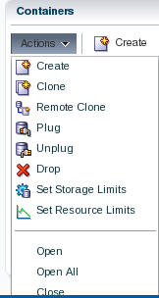

* Accept the defaults and Click **OK**.

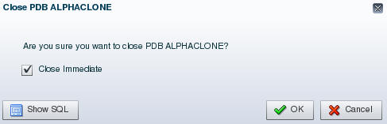

* Close the Confirmation pop up by clicking **OK**.
* Reopen the pluggable database via **Actions 🡪 Open**.
* Accept the default to open it Read / Write. Click **OK**.

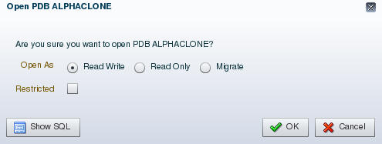

* Close the Confirmation pop up by clicking **OK**.
* Refresh the browser page using the refresh icon in the top right corner.

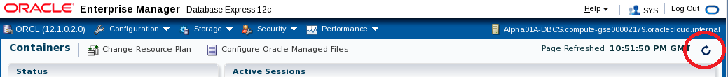

* Note that the violations are now gone.

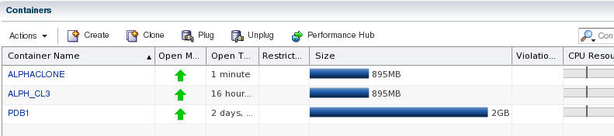

* Click the ALPHACLONE container name link to review the database information.

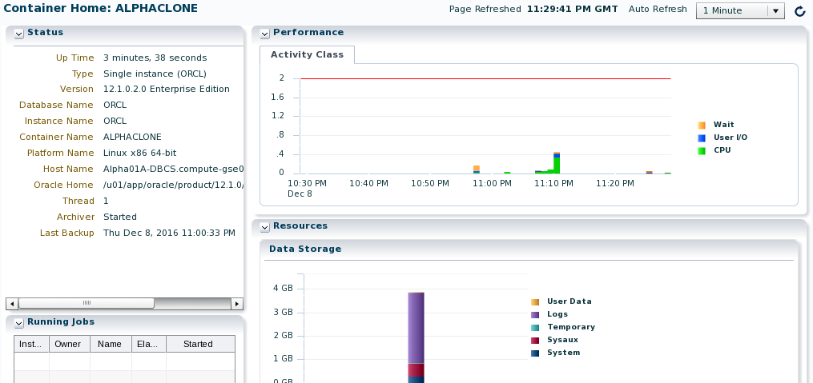

#### Create an SQL Developer connection to the Public Cloud database ALPHACLONE schema

* In the SQL Developer application, click the green plus sign  in the Connections window to create a new connection; enter the following connection details:

|  |  |
| --- | --- |
| **Connection Name:** | Alpha Clone – DBCS |
| **Username:** | alpha |
| **Password:** | oracle |
| **Check:** | “Save Password” |
| **Connection Type:** | SSH |
| **Service Name:** | Alphaclone.<Your ID Domain>.oraclecloud.internal |

***Note:*** *You can optionally select a color for the connection to differentiate it from other connections.*

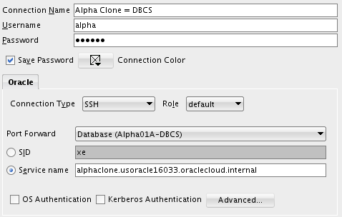

* Click Test to confirm the information was entered correctly.

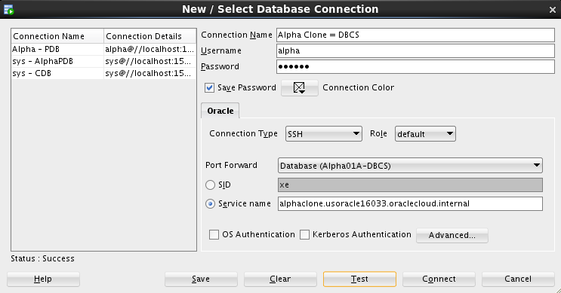

* Click Connect to save the connection information and open a new SQL Worksheet.

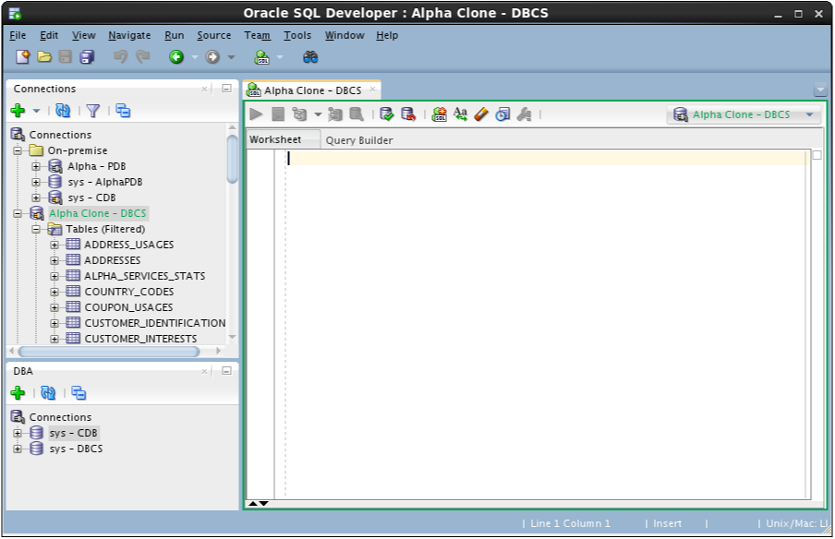

* You have successfully migrated a pluggable database from on premise to the cloud. In the next section we’ll migrate data using Data Pump.

### Cloud Migration Using Data Pump

#### Export the Alpha Schema

The first step will be to create a local Data Pump Directory.

* In the Connections Tab inside the "On-Premise" folder navigate to the Alpha - PDB 🡪 Directories item, right-mouse click and select Create Directory…

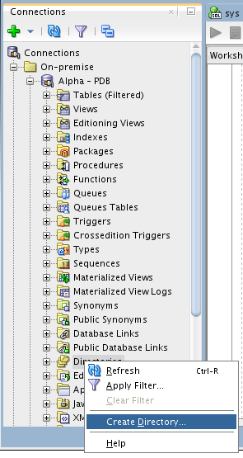

**Note**: The default Data Pump directory object, DATA_PUMP_DIR, does not work with PDBs. Data Pump requires an explicit directory object within the PDB for exporting or importing schemas or tables.

* Enter the following values and click Apply. Remember to use the SQL tab to review the actual DDL statement. Click OK to dismiss the confirmation.

|  |  |
| --- | --- |
| **Directory Name:** | alpha_backup_dir (not case sensitive) |
| **Database Server Directory:** | /u01/OPCWorkshop |

**NOTE:** You may receive an error message stating that “An error was encountered performing the requested operation:” and that the directory cannot be created. To eliminate this error right-click on Alpha - PDB and choose Disconnect. Then Reconnect. The error occurs because you were connected earlier while performing the UNMOUNT / REMOUNT and during the previous “cloning” of the PDB container the connection information was lost. Reconnecting will normally solve this issue.

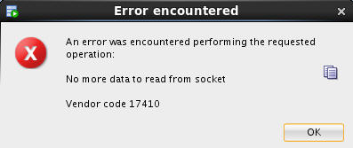

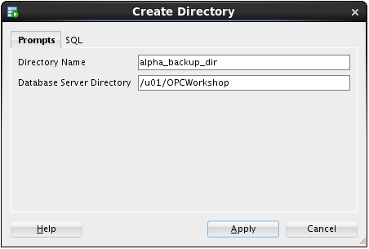

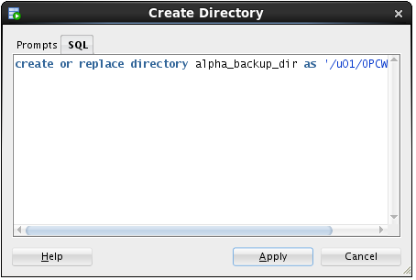

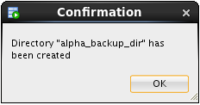

**Stop here-------**

* Now that we’ve created the Data Pump export directory the next steps will outline how to create and run a Data Pump Export job using SQL Developer
* In the DBA Window, Add Connection by clicking on the Green Plus sign.

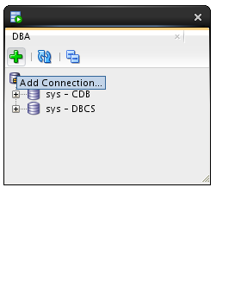

* Select the Alpha - PDB connection and click the OK button.

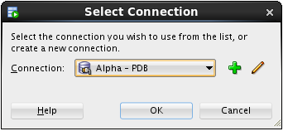

* Expand Alpha - PDB, expand Data Pump, then right-mouse-click on Export Jobs, and then select the Data Pump Export Wizard… menu item.

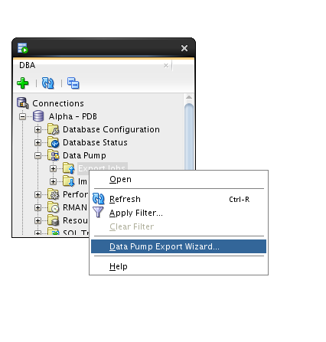

* Select the Schemas export type and click the Next button.

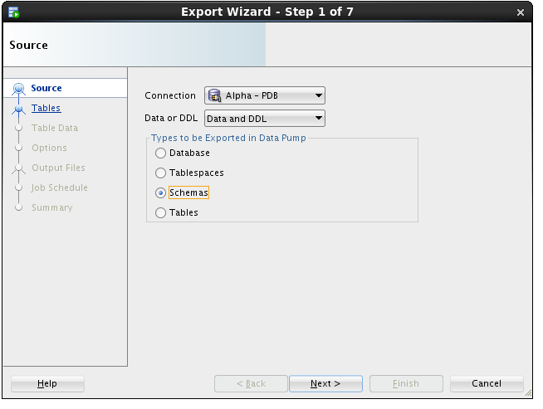

* Select the ALPHA schema and use the blue arrow to move it to the right-hand column. Click Next.

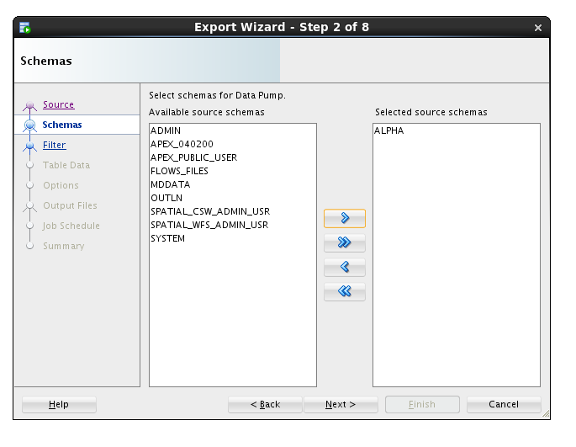

* We are not filtering out any objects, click the Next button.

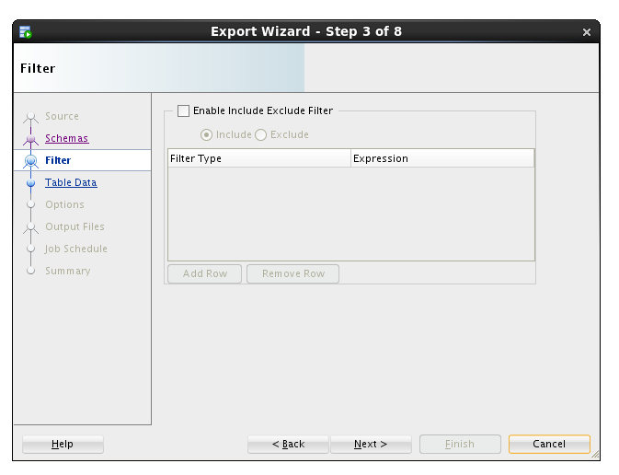

* We are not applying where clauses to table data, click the Next button.

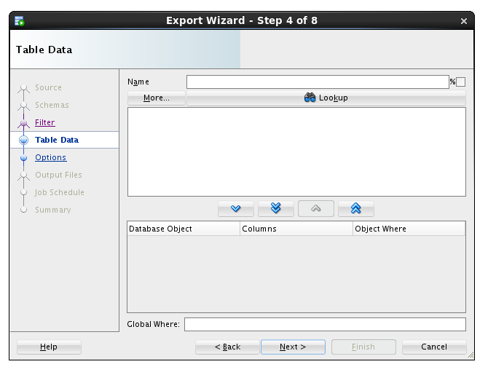

* We want a log for this export, and just like the actual export file, we must pick a directory from the list of directories in the database.
* Select ALPHA_BACKUP_DIR from the list and click the Next button.

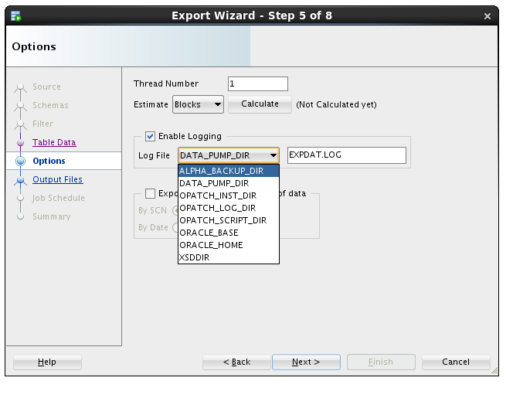

* The most important selection for any Data Pump operation is choosing the directory where the export file will be written.
* Select ALPHA_BACKUP_DIR from the Directories drop down list.
* Then, select the Delete Existing Dump Files radio button and click the Next button.

**Note**: Data Pump always uses a server side directory for all export or import operations.

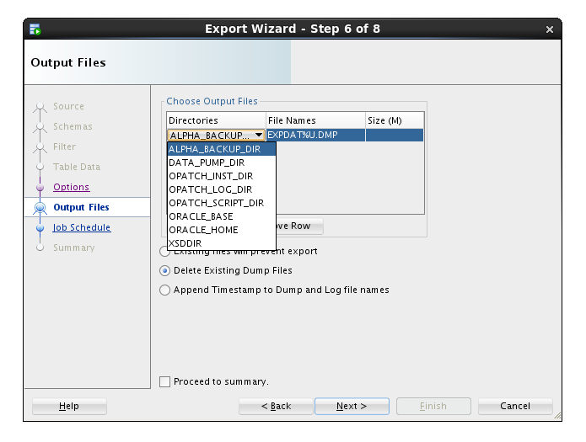

* Data Pump jobs can be scheduled to run at any time and on any desired times of the day, week or year. We will run the job immediately - click the Next button.

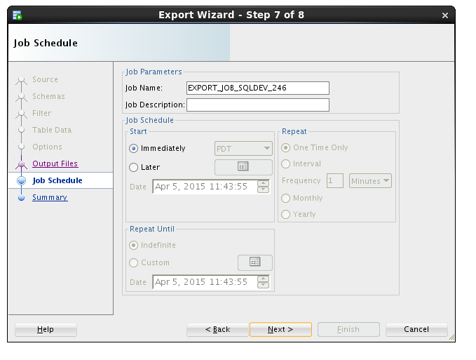

* On the Summary panel, click the PL/SQL tab to review the job definition. Review the PL/SQL use of Oracle Supplied PL/SQL subprograms for Data Pump. Click the Finish button to create the job.

|  |  |
| --- | --- |
|  |  |

* For a brief time, SQL Developer shows a progress dialog while it creates the job in the database.

**Note:** the import actually runs as a job in the database so this message is only about creating and scheduling the export.

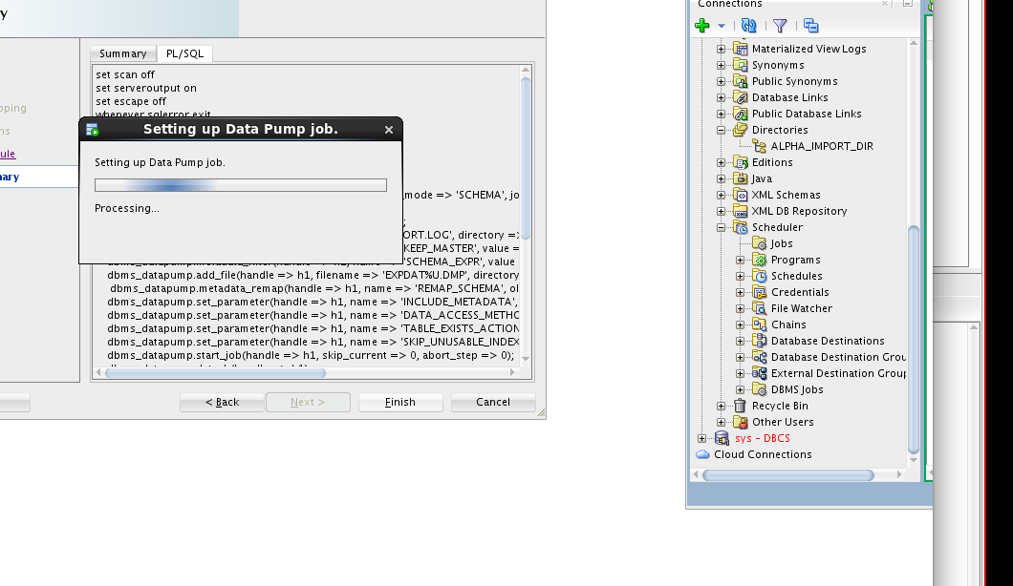

* While the job is running, you may view status information by clicking on the export job added to the DBA Navigator panel. It may take a couple of minutes so click the Refresh icon until the job is completed (NOT RUNNING).

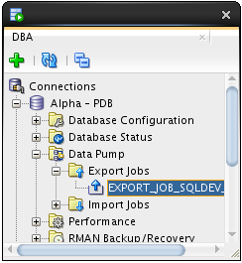 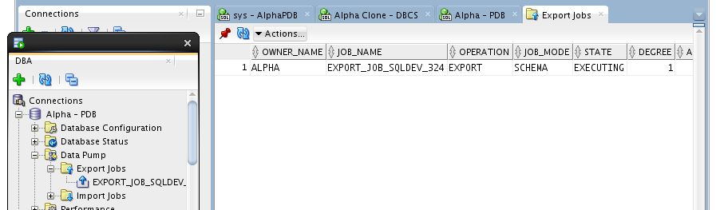

* Now we’ll copy the export Data Pump file to the server
* Start a Terminal window using the top panel icon.

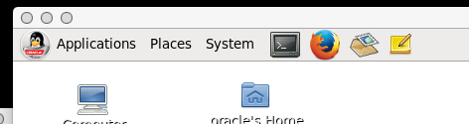

* Enter the following commands to print the working directory (pwd), list the directory (ls) contents and review the Data Pump log file.

$ pwd

$ ls

$ cat EXPDAT.LOG

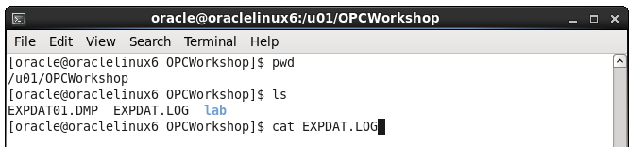

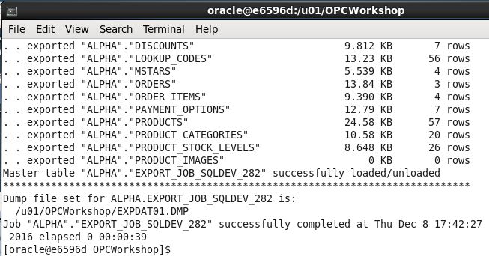

Use the following secure copy (scp) command to transfer the Data Pump export to the DBCS server. Use the Database Service Private IP address you identified in the first lab.

$ scp -i lab/labkey EXPDAT01.DMP oracle@<Alpha01A-DBCS public IP>:~

***Note:*** *the tilde (~) represents the oracle user's home directory.*

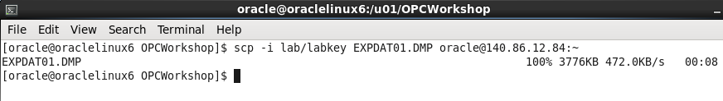

#### Import Alpha to a new Schema

* As we begin the import phase of this example we’ll first create an import directory in the Alpha Clone PDB.
* Use SQL Developer and expand the Alpha Clone - DBCS connection.
* Right-mouse-click on the Directories tree item and select the Create  Directory… menu item.

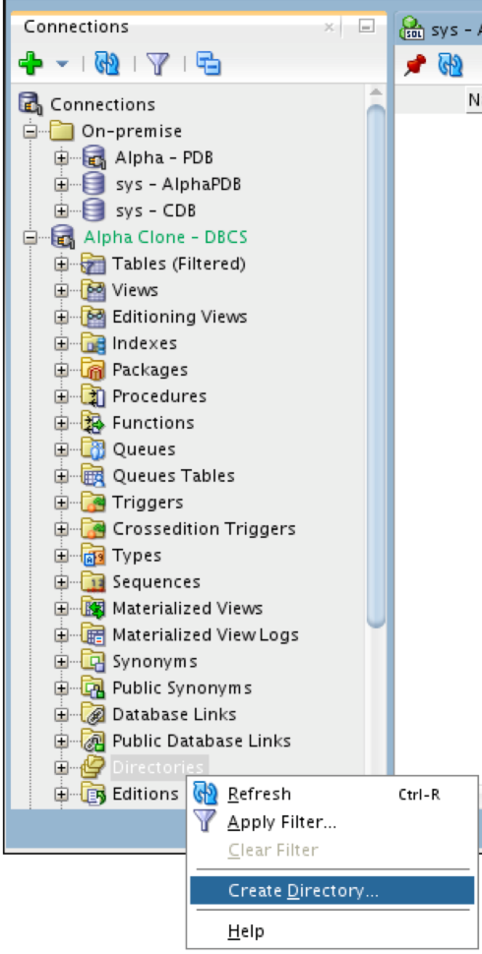

* Enter the following values and click the Apply button.
* Click OK to dismiss the confirmation message. This lets the database access the same directory where the Data Pump export file was copied.

|  |  |  |  |
| --- | --- | --- | --- |
| ***Directory Name:*** | alpha_import_dir | | |
| ***Database Server Directory:*** | /home/oracle | | |
|  | |  |  |

* The next few steps will outline creating the Data Pump Import job. To access the Data Pump features, we need to add the clone connection to the DBA Navigator.
* Click on the green plus sign, Add Connection icon on the DBA Navigator panel



* Select Alpha Clone - DBCS connection and click OK.

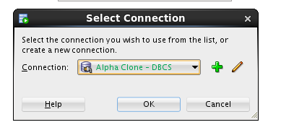

* Expand Alpha Clone - DBCS 🡪 Data Pump
* Right-mouse on the Import Jobs menu item, and select Data Pump Import Wizard… menu item.

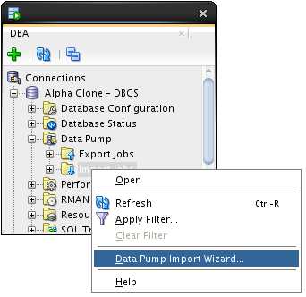

* Select Schemas from the ‘Type of Import box and Choose ALPHA_IMPORT_DIR from the ‘Choose Input Files’ drop down list, then click Next.

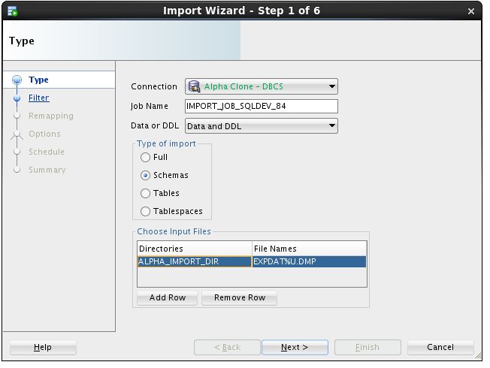

**Note:** This action might take a few minutes. There is some wait time while the database locates and scans the import file in the selected directory.

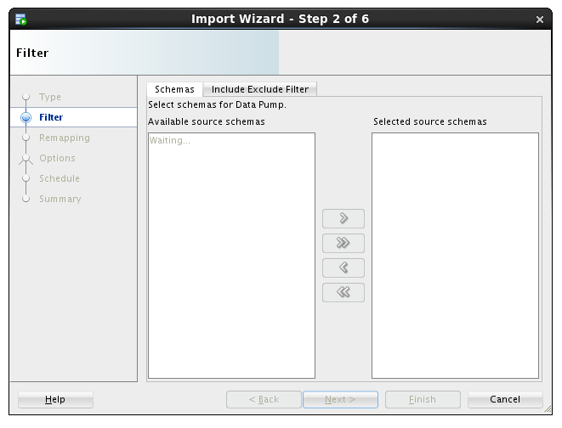

* Move the ALPHA schema from the left to the right column using the arrow button and click Next.

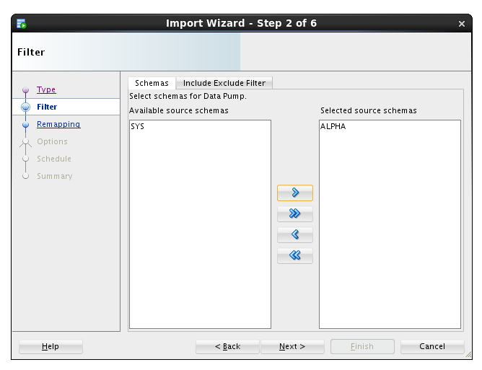

* For this lab, we are creating a new schema, so we will enter the new schema name as the destination.
* Under the Re-Map Schemas section click Add Row.
* Enter the following values and click the Next button.

|  |  |
| --- | --- |
| **Source:** | ALPHA (should be the default item) |
| **Destination:** | ALPHA_COPY |

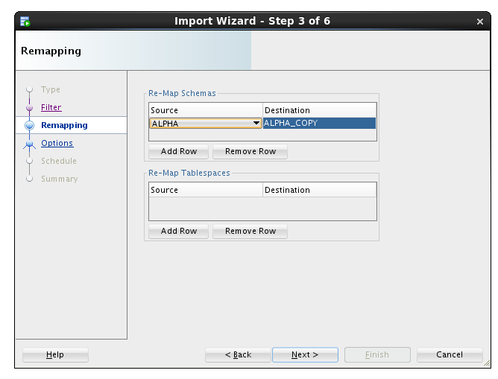

* We want to see the log output so we will select the same directory as the import file directory.
* Select ALPHA_IMPORT_DIR and click the Next button.

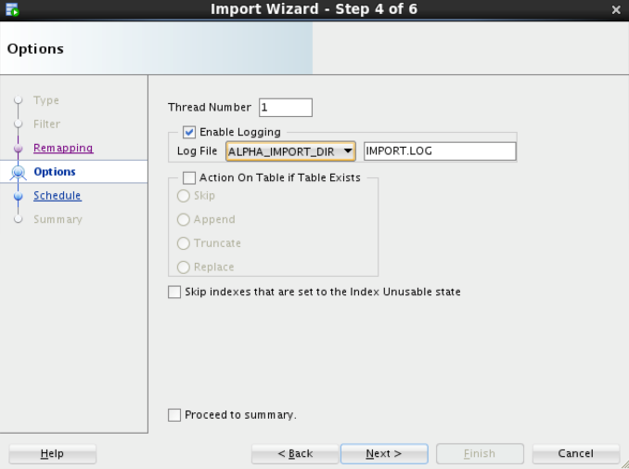

**Note:** For lab purposes we will execute the import immediately. In normal operations this job could be set up to refresh a development database on a daily basis.

* Click the Next button.

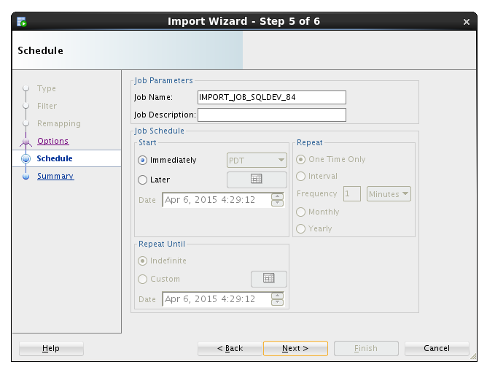

* Click the PL/SQL tab to review the small program that establishes the import job. Click the Finish button to create the job.

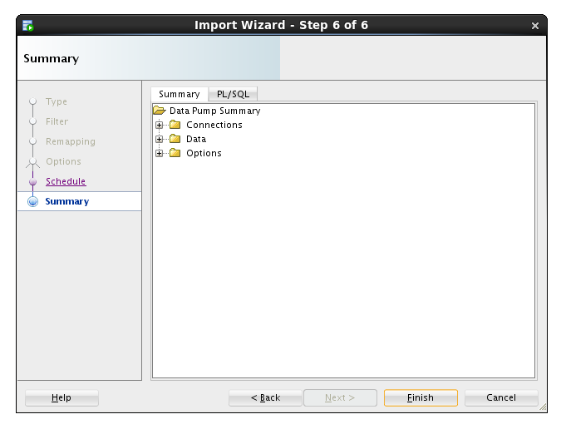 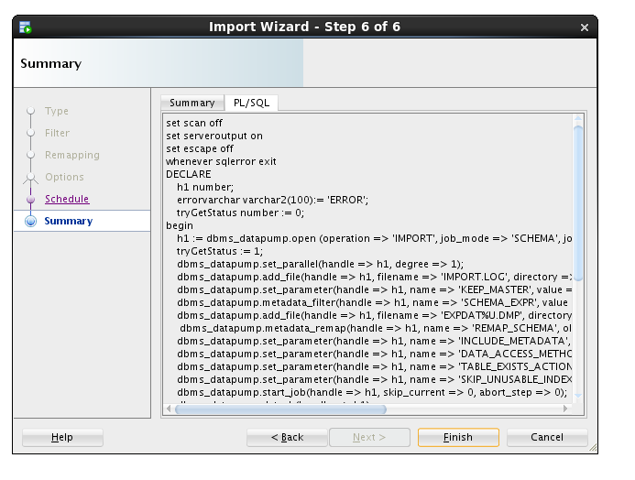

**Note:** For a period of time SQL Developer shows a progress dialog while the job is being created. The job does not run locally you’re seeing the progress of creating the job in the database.



* Locate and click on the job name to see the detailed status as the job runs. When the job completes, the database automatically removes the job. You will need to use the Refresh icon  to see when the job finishes.

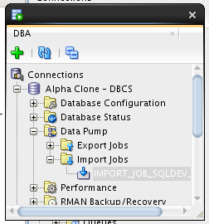 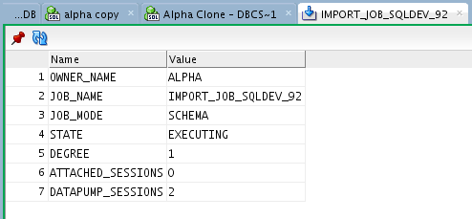

* If you are interested in verifying that the ALPHA_COPY schema is the same as the ALPHA schema, feel free to create a connection and compare.

### Cloud Migration Using SQL Developer Carts

#### Creating an SQL Developer Cart

The SQL Developer Cart is a convenient method for organizing the deployment of database objects and data from one database to another. In this trivial example, we want to update the data of just the CUSTOMERS and PRODUCTS table in the development cloud database. More elaborate usages of the cart can help package entire application deployments, including pre and post processes from multiple data sources.

* Show the Cart using the View > Cart menu option.

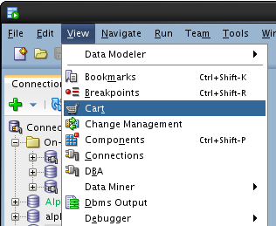

* If Cart_1 is not already created (it should be), Click on the New Cart icon.

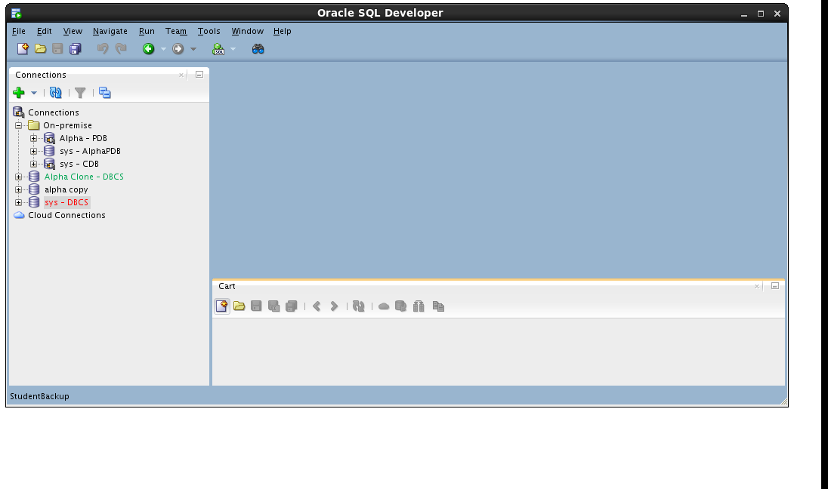

* Drag the CUSTOMERS table from the Alpha - PDB connection to the cart.

 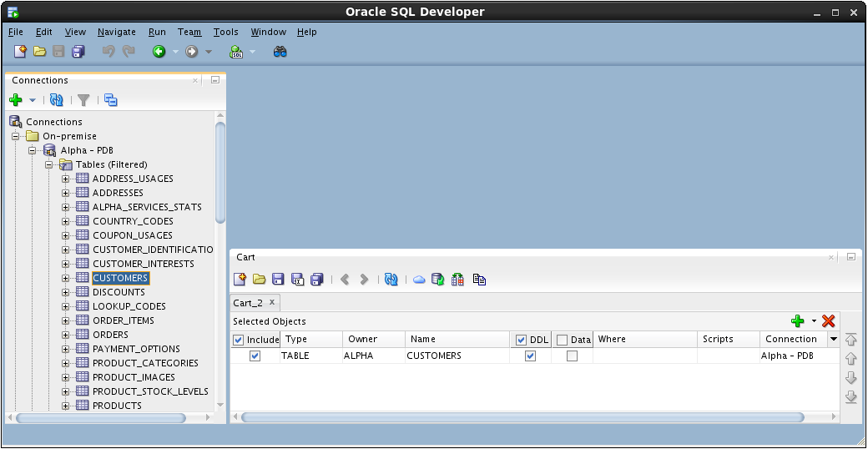

* Drag the PRODUCTS table to the cart.

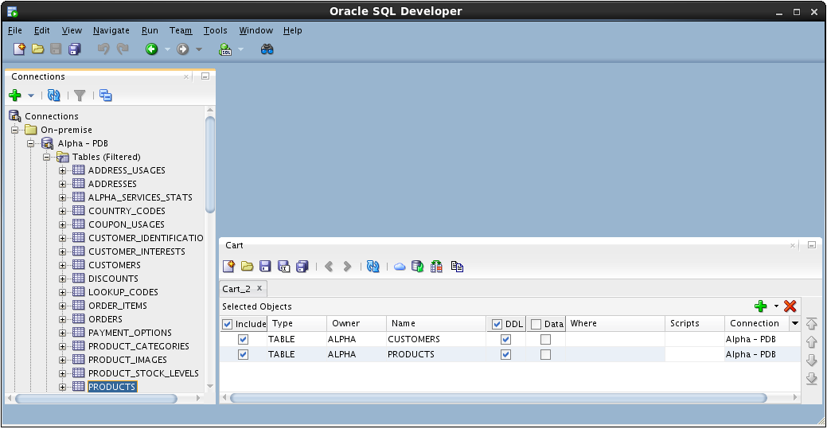

* Include a script that runs before any other Cart activity. For this lab, we are disabling all the referential integrity constraints so we can delete and insert data without regard to foreign keys on our tables.
* In the Cart window click small down arrow next to the green plus “+” icon and select Add Initial Script

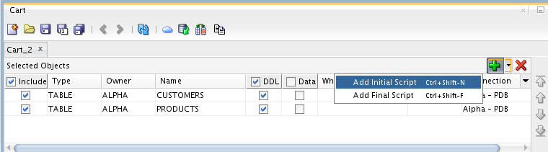

* Click the Browse… button.

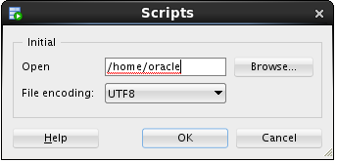

* Locate the following file and click Open:

/u01/OPCWorkshop/lab/disable-constraints.sql

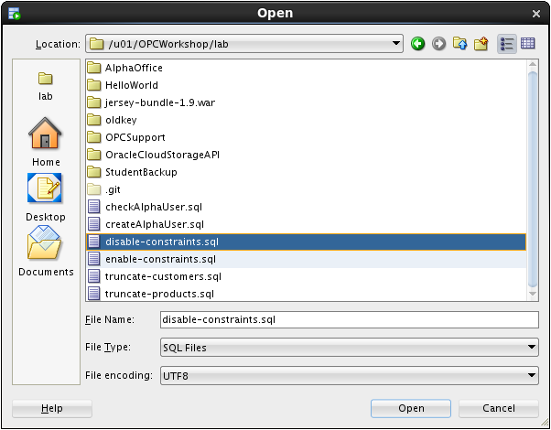

* Click OK.
* Click the down arrow next to the green plus “+” icon again and select Add Final Script which is included as the last operation performed during the cart operations.

**Note:** There can only be one Initial or Final script in a Cart.

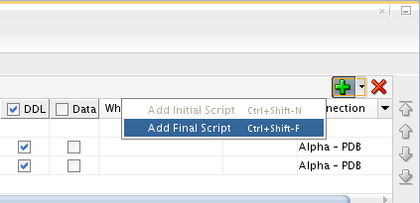

* Click the Browse… button

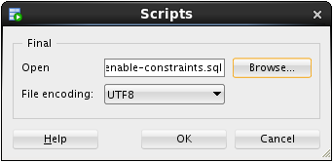

* Locate the following file and click Open:

/u01/OPCWorkshop/lab/enable-constraints.sql

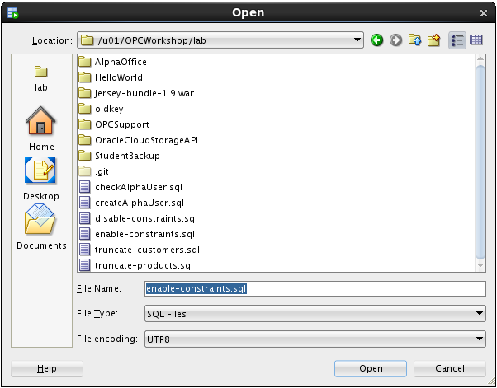

* Click OK.
* We are not creating any tables in this lab; uncheck the DDL column heading.

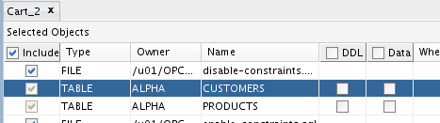

* We will move the data, include a check the Data column heading.

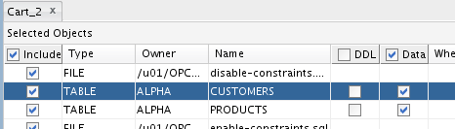

* Before we can overwrite the new rows in the CUSTOMERS table, we need to truncate the table.
* Click in the Scripts column cell for the CUSTOMERS table and then click the pencil icon.

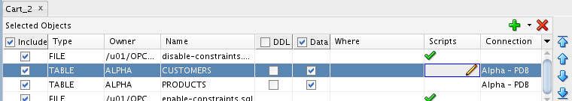

* Check the Before Load box, then click the Browse… button and select the following file:

/u01/OPCWorkshop/lab/truncate-customers.sql

* Click OK:

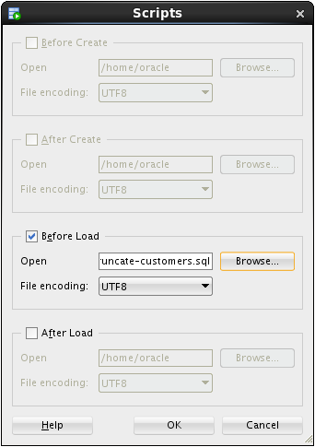

* Repeat the operation for the PRODUCTS table; click the pencil icon on the products row.

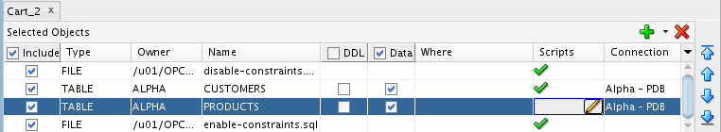

* Click the Before Load button, then click on the Browse… button and select the following file:

/u01/OPCWorkshop/lab/truncate-products.sql

* Click OK:

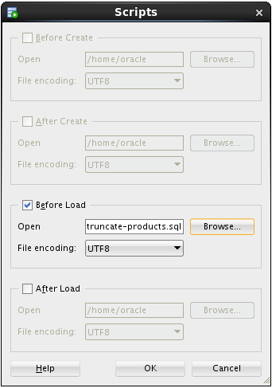

#### Export the SQL Developer Cart

* Now that the cart is complete, click the Export Cart toolbar icon to generate the script of all the elements we inserted in the cart.

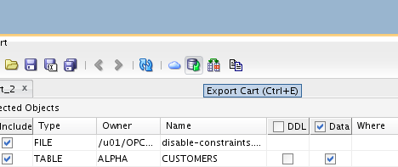

* Click the Apply button to generate script.

**Note:** The selections on this page may be saved and later reused if the cart is regularly used the same way.

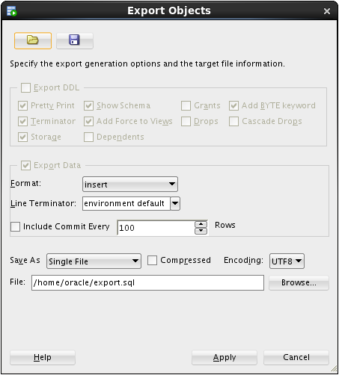

* If the file already exists, SQL Developer asks you to confirm overwriting it with new content. If you see this prompt, click the Yes button.

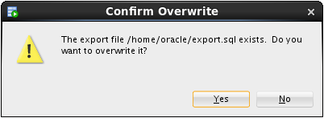

* Review the contents of the script with particular attention to the SQL statements that have been inserted based on the scripts we included.

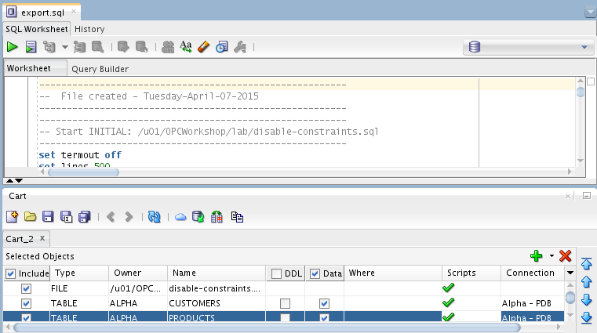

* Run the script by clicking the Run Script icon and selecting the Alpha Clone — DBCS connection.

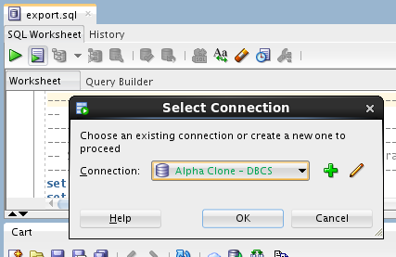

* Click OK.
* SQL Developer shows a progress bar while the script runs. Depending on your window layout, you may see the command output scrolling by while the script runs.

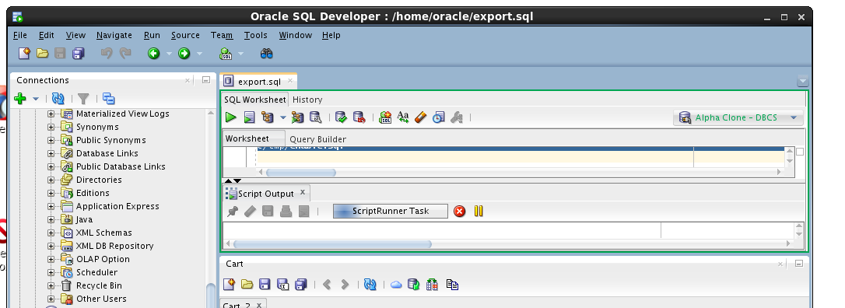

* When the script is complete, review the script output looking for the execution of both the script elements and the DML statements.

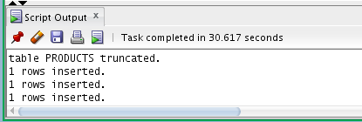

* This concludes Lab 2 – Cloud Migration, proceed to the next lab when you’re ready.

# Backup and Recovery

### Introduction

Oracle Database Backup Service (ODBS) is a new backup-as-a-service offering that enables customers to store their backups securely in the Oracle cloud. ODBS provides a transparent, scalable, efficient, and elastic cloud storage platform for Oracle database backups. The Client side Oracle Database Cloud Backup Module which is used with Recovery Manager (RMAN) transparently handles the backup and restore operations.

Oracle Database Cloud Backup Module is the cloud backup module that is installed in the database server. During the install process, a platform specific backup module is downloaded and installed. The RMAN environment of the client database is configured to use the cloud backup module to perform backups to ODBS. Using familiar RMAN commands, backups and restores are transparently handled by the cloud backup module.

### Objectives

* Install the Oracle Database Cloud Backup Module onto the VM image provided in the workshop. The database provided in the VM represents the on premise database in a typical customer situation.
* Configure RMAN to support the Oracle Database Cloud Backup Module. Then, backup the database and take a restore point to be used for Point-In-Time-Recovery.
* Simulate a destructive database operation and then restore and recover to a specific Point-In-Time.

### Lab Requirements

* VNC Viewer to access the client system

### Oracle Public Cloud Backup Recovery

#### Start the On-Premise Oracle Database

* Access the Virtual Client image following the prior instructions regarding the VNC viewer.
* If your local database is not running for some reason (it should be at this point) locate and double-click the StartDB icon.

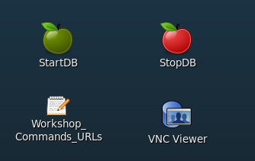

#### Install the Cloud Backup Module

* The .jar file (opc_install.jar) used to install the Cloud Backup Module has already been placed into the /u01/OPCWorkshop/lab directory.
* Open a Terminal Window, cd into the lab directory and execute the following OS commands to verify that opc_install.jar exists.

$ cd lab

$ pwd

$ ls *.jar

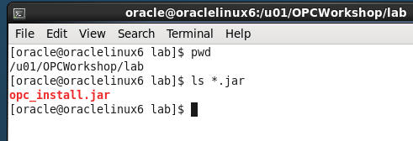

* The installation command with all of the options is rather lengthy. In order to make things easier for you and eliminate potential typos the installation command has been saved into a text file named Workshop_Commands_URLs.txt. The file is represented by an icon on the Client Image Desktop.
* Double click on the Workshop_Commands_URLs.txt icon to open up the file.

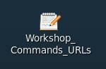

* Find the “**OPC Cloud Backup Installation**” section in the text file.
* Replace <opc-identity-domain> <opc-username> and <opc-passwd> (including replacing the <>) with the **Identity Domain, Username, and Password** student account information you were assigned. Also, be sure to put single quotes around your password to avoid any issues with special characters.
* Before:

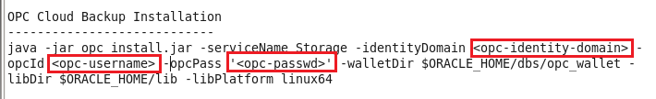

* After

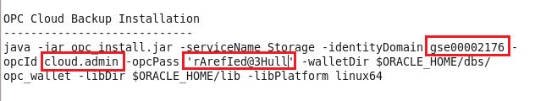

* Copy and Paste the updated command from the text file into your terminal and hit Enter.

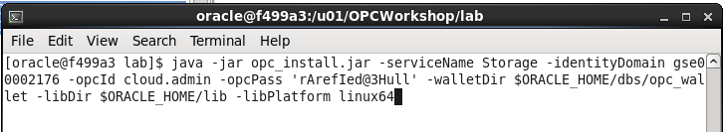

* The installation command creates a configuration file “**opcorcl.ora**” and wallet directory “**opc_wallet**” and places these in $ORACLE_HOME/dbs. It also downloads a library file “**opclib.so**” that RMAN uses to communicate with the Oracle Database Backup Service and places that in $ORACLE_HOME/lib. You specified these locations in the syntax of the install command.